# Worksheet 1: File management

# Task 1: File types

Complete the table using the following file extensions. Some types of file may have more than one possible extension:

**.xls .mov .doc .jpg .png .docx .exe .ppt . accdb**

|  |  |
| --- | --- |
| **Type of file** | **File extension** |
| A PowerPoint presentation | .ppt |
| An image or photograph | .jpeg or .png |
| An Access database | .accdb |
| A Word document | .doc |
| An executable file | .exe |
| A video | .mov |
| A spreadsheet | .docx |

# Task 2: File management

1. Describe **two** ways you can open File Explorer on your computer

You can open file explorer from the start menu or with the windows e shortcut

1. Give the shortcut key combinations for the following operations:
   1. Copy Control C
   2. Paste control v
   3. Save control s
   4. Undo control z
   5. Add **two** more of your own and say what they are used for:

Control alt delete, very useful for potatoes, and control a for highlighting all of the text on a doc.

1. (a) Copy the folder named **UCSER Folder Structure** into your own area on the school computer. Imagine that you use this folder to save documents for English, Geography and Computing. You also occasionally save articles and photos that are to go in the school magazine, which you are helping to edit. done

(b) Add three more suitably named subfolders in appropriate places to hold **Computing Worksheets**, **Computing homework** and **magazine articles** for the school magazine. oke

(c) Move the files named **Swimming success.doc** and **School play.doc** into the folder for **magazine articles**.

(d) Rename the file **School play.doc**, calling it **Arabian Nights.doc**

(e) Use the **Search facility** to find the file which, as far as you remember, has **UK** as part of the title. What is its full name?

The geography of the uk

(f) What does the **School Magazine** folder contain?

Arabian nights and swimming success

(g) Draw the folder structure after these amendments, showing folders and subfolders.

What?? I can’t I am on computer!!!!!!

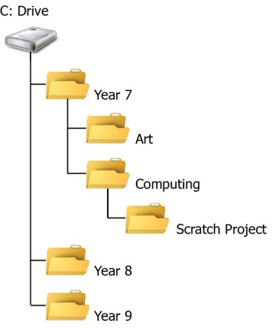

**Example**